Table Products

Table Customers

Table Orders

Table Order_Items

Query 1 - Retrieve the **names** and **stock quantities** of all products.

Query 2 - Retrieve the product names and quantities for one of the orders placed.

Query 3 - Retrieve all orders placed by a specific customer (including the ID’s of what was ordered and the quantities).

**Update Data**: Perform an update to simulate the reducing of stock quantities of items after a customer places an order. Please describe or indicate which order you are simulating the reducton for

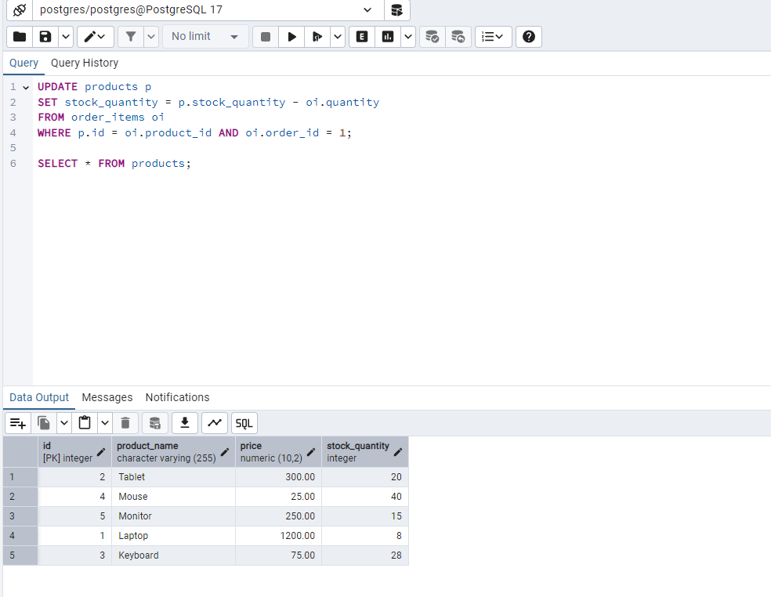

**Delete Data**: Remove one of the orders and all associated order items from the system.

